**Tutorial 10, CS1031**

1. You want to digitise a voice conversation in order to record it on a memory stick. Assume that the highest frequency component of the voice signal is 10KHz and you encode it using 16 bits per sample.
   1. What are the minimum sampling frequency and the minimum bit rate required by your system?
   2. Draw the spectrum of the digitalised signal obtained using the minimum sampling frequency, assuming the spectrum of the original analogue voice signal is like the one in Figure 1.
   3. Draw the spectrum of the digitalised signal, when the sampling frequency is 30 KHz.
   4. Draw the spectrum of the digitalised signal, when the sampling frequency is 15 KHz. Then explain what the problem is created by this sampling frequency.

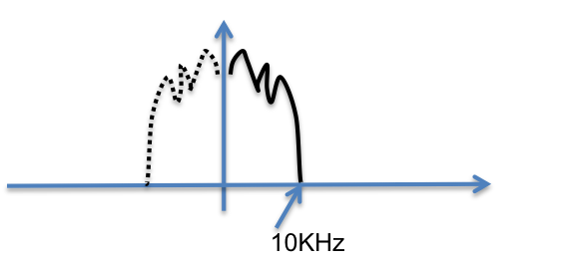

 Figure 1: Spectrum of the original analogue voice signal

1. The minimum rate is obtained by sampling at twice the max frequency and multiplying by the bits per sample, thus: 20KHz x 16 = 320Kb/s
2. The min. sampling frequency is 20 kHz, which ensures that the spectra of the digitized signal do not overlap.

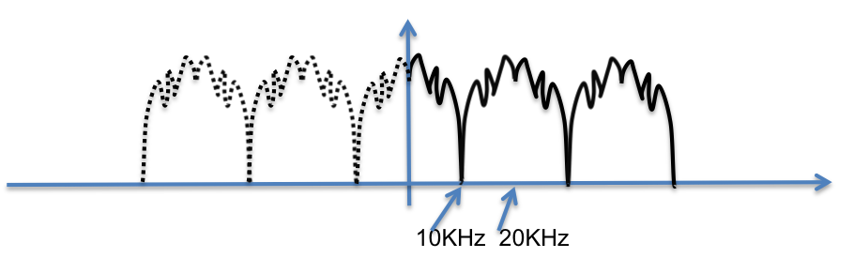

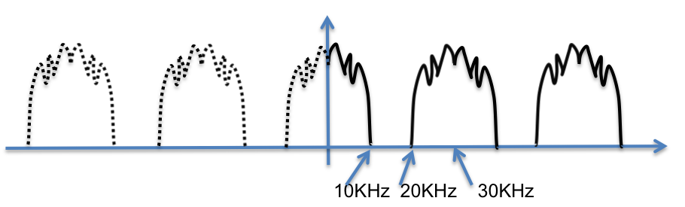

1. For the sampling frequency of 30 kHz there is a 10 kHz spacing between the spectrum replicas of the digitized signal.

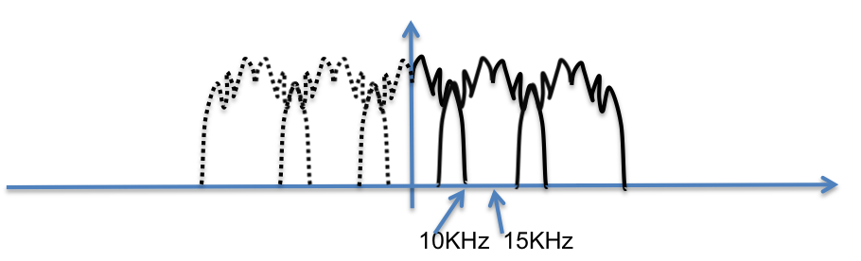

1. For the sampling frequency of 15 kHz, the spectra of the digitized signal overlap causing aliasing.
2. To transmit a voice signal over a walkie talkie radio, with a frequency spectrum similar to the one shown in the figure below, we use the carrier frequency of 100 kHz. The radio is digital, thus, you need to sample, quantize and modulate the signal.
3. Specify the sampling rate and quantization you would use and state what bandwidth you require if the maximum number of levels allowed by your digital modulator is 32.
4. What could you do if you needed to reduce the bandwidth of the signal to less than 10 kHz (still the maximum number of levels allowed by your modulator is 32).
5. Show a plot of the frequency spectrum of the modulated signal of point (a).

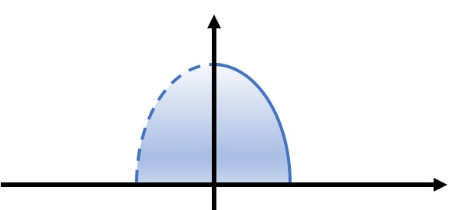

10kHz

1. The minimum sampling rate is 20 kHz (2xfmax). It is sufficient for the voice to be encoded using 8 bits/sample. Thus, the raw bit rate would be 20 000x8=160000 bit/s.  
   Assuming 32 level modulation i.e. 5 bits/symbol, the bandwidth required would be:

B=(1+d)S (d=1)

S=R/n (n=5bits/symbol)

B=2*R/n=2*160,000/5

B=2*32,000Hz = 64,000= 64kHz

1. In order to reduce the bandwidth requirement, we can filter the voice signal using a low-pass filter with 4kHz bandwidth. This would reduce the sampling frequency to 8kHz, bit rate to 64 kb/s (8bits/sample * 8 kHz) and the transmission bandwidth (using 32 level modulation) to 25600 Hz (25.6 kHz).

Note that filtering reduced the voice bandwidth 2.5 times and since all the other parameters remain the same, the transmission BW also is reduced 2.5 times (25.6*2.5=64).

1. The spectrum would be moved to +/- 100 kHz and will have the BW=64 kHz



1. An optical system is used to transmit 12.5 Gb/s data signal on-off keying (binary amplitude modulation) over 200 km of fiber single mode fiber (D=17 ps/(nm⋅km). The wavelength of the signal is 1550 nm.
   1. Calculate the total dispersion accumulated over the transmission distance.
   2. How many km of dispersion compensating fiber would you need to use, in order to compensate for this amount of dispersion, assuming the dispersion coefficient of the DCF is D=-90ps/(nm⋅km).
2. Calculate the frequency of the optical carrier:

The spectral width of the signal at 12.5 Gb/s can be now calculated given the formula:

(since the frequency difference is much smaller than the frequency you can assume ). The BW of a modulated signal is equal to 2xR=25GHz

Thus, the accumulated dispersion after 200 km transmission is:

1. The length of DCF with D=-90ps/(nm⋅km) can be calculated

or L